Chemistry 125 Laboratory
Fall 2009

Extraction of Caffeine from Tea (Week I)

Just about everyone knows how to get caffeine out of tea leaves: steep them in hot water. That also releases lots of other compounds into the water to make a tasty (although opinions vary) beverage. In this experiment, you will make a nice cup of tea, and extract the caffeine. As a group, we will use various techniques to isolate the extracted caffeine.
These extraction techniques will be important as we consider how other compounds may be extracted from plastics and other material. Also of note, the extraction of organic compounds from natural sources is a primary method of obtaining new drugs for use in treating diseases.

Caffeine is a member of the class of compounds organic chemists call alkaloids. Alkaloids are nitrogen- containing basic compounds that are found in plants. They usually taste bitter and often are physiologically active in humans. The names of some of these compounds are familiar to you even if the structures aren’t: nicotine, morphine, strychnine, and cocaine. The role or roles these compounds play in the life of the plants in which they are found is not well understood. In some cases they may act as pesticides; nicotine is found in tobacco and has been sprayed onto other plants, in which it is not found, to function as an insecticide. The structure of caffeine is shown to the right. It can be considered to be constructed from the purine ring system, which is important biologically, being found in nucleic acids and elsewhere.

Procedure. Make a nice strong cup of tea: In a 250mL beaker, pour 100 mL of boiling water over 6 tea bags and allow the beaker to stand for 10 min. with occasional stirring. Decant the tea from the tea bags into a second beaker and compress the tea bags to maximize solvent recovery. In the original beaker, and repeat this extraction using 25-mL of boiling water.
Combine the aqueous extracts, and stir in 26 g sodium chloride and 1g NaOH. Cool to room temp. and pour into a separatory funnel with 20mL 1-propanol. (Your instructor will show you how to use a sep. funnel). Gently swirl the funnel, then drain the lower layer back into your ‘tea cup’ from before, and add the top layer to a clean Erlenmeyer flask. Add the tea back into the sep. funnel with a new 20mL portion of 1-propanol and repeat the extraction and separation. Perform a third extraction, combining all propanol layers in the flask.

Group 1: Add anhydrous sodium sulfate to dry the extract in your flask. (Sodium sulfate will ‘soak up’ the water that mixes with the propanol. “Dry” in this context means, “having no water,” not “having no liquid.”) Decant or filter the solution into a new flask. Heat the flask in the hood, while gently blowing air over the solution to evaporate the solvent, leaving the crude caffeine.

Group 2: Perform the same steps as group 1, but scrape the crude product into a flask provided by your instructor to show purification by sublimation.

Group 3: Pour the solution from the flask back into the sep. funnel. Add 15mL 10% NaOH solution, shake, allow the layers to separate, and drain the lower layer. Repeat. Return the top layer to the flask and perform the drying and evaporation as indicated for group 1.

All Groups: Save your caffeine in a vial for next week, when we’ll evaluate more methods to separate compounds and check their purity.

In your report, calculate the percentage of caffeine you recovered from your tea leaves. Assume that the average tea bag has 2.3g of tea leaves, and that the leaves are4.0% caffeine by mass.
Analysis of caffeine samples extracted from tea leaves
Chem 125- Week II

Background
Goals
In this week’s laboratory experiment, you will be assessing the purity of the caffeine that you extracted from tea leaves. You will use three complementary techniques. With thin layer chromatography (TLC), you will physically separate caffeine from impurities on the basis of chemical properties such as polarity. Using UV-Vis and IR spectroscopy, you will assess the purity of your samples on the basis of the spectral resolution that can be achieved when chemicals in a mixture sample absorb light at different wavelengths depending on the characteristics of their functional groups. With UV-Vis, you will go one step further and calculate the concentration of your sample after establishing a calibration curve using caffeine standard solutions.

Thin layer chromatography

The main new technique that you will be using this week is thin layer chromatography (TLC). As the name indicates, TLC is one of the major chromatographic techniques that are used every day in the industry. It is often used by chemists to determine the number of components in a mixture, identify substances in a mixture, and follow the progress of chemical reactions. While the goal of this week’s laboratory is not to cover the theory of chromatography in detail, it is important to discuss the basics.

Chromatographic separations rely on the possibility that compounds can partition between two phases, a mobile and a stationary phase, based on their physicochemical properties. In TLC, the mobile phase is a liquid (eluent) while the stationary phase is a material such as silica or alumina coated on a solid backing (e.g. glass or plastic or aluminum). The mixture of interest is applied near the bottom of the so-called developing plate, which is placed upright in a sealed tank containing a small amount of eluent at the bottom. The mobile phase will rise on the TLC plate due to capillary action. Once the plate has been developed in the tank, it is removed from the tank and allowed to dry until the solvent(s) has evaporated. The spots are usually visualized using UV light. Since the stationary phase usually contains a fluorescent background, substances that absorb UV light appear as dark spots under UV light due to “quenching” while the rest of the plate fluoresces.

If the TLC plate is coated with a polar material as it is the case in normal phase chromatography, the eluent used is relatively non-polar to enhance separation of substances based on polarity. The behavior of substances during an elution is an equilibrium process with regard to their partitioning between two phases. Substances that are very polar will spend more time adsorbed to the stationary phase and move more slowly than substances that are less polar since these latter ones will spend more time dissolved in the mobile phase. Therefore, separation is obtained based on the different polarities of the various substances in the mixture. In reverse phase chromatography, the stationary phase is non-polar while the eluent is relatively polar.

To express TLC results, retention factors or Rf values are calculated. The Rf value of a substance is the relative distance that the substance has moved with respect to the mobile phase. For instance, if the distance traveled by a substance is 3.0 cm while the eluent has moved over a distance of 6.0 cm, the Rf value is 3.0 cm/6.0 cm = 0.50. As you may have noticed, Rf values are dimensionless and quite convenient since Rf values obtained using the same the mobile and stationary phases should consistently be the same wherever the experiments are done and whatever the time of the elution is. Please note that keeping Rf values between 0.1 and 0.9 is preferable.

Several parameters influence the efficiency of a TLC separation, i.e. the resolution of the spots from a multi-component mixture. The main two factors include the eluent type and the developing plate. An ideal eluent will lead to the separation of the substance of interest from impurities or other components based on polarity. It will allow all substances to move at a reasonable rate, i.e. not too fast to avoid their moving as fast at the mobile phase, or not too slow to prevent their sticking to the plate where they were spotted. Finding the right balance of polarities for the solvents constituting the mobile phase is based on trial and error after consulting tables of solvent polarities (please see table below).

Solvents for TLC in order of increasing polarity and “solvent power” toward polar functional groups
Petroleum ether
Cyclohexane
Carbon tetrachloride
Toluene
Chloroform
Methylene chloride
Ethyl acetate
Acetone
Pyridine
Ethanol
Methanol
Water
Acetic acid
Source: “Introduction to Organic chemistry”, 4th ed. by Pavia, Lampman, Kriz, and Engel, Thomson Brooks/Cole: Belmont (2007).

Since the stationary phase is usually already defined for a given separation, the adjustments made to obtain a satisfactory TLC separation rely on mixing different solvents in the right proportions. . If the stationary phase is polar (e.g. silica gel or more precisely silicic acid, which is highly polar), non-polar solvents are usually used as the base of the mobile phase. Then solvents with intermediate polarity can be added at a level between 1 and 50%. Very polar solvent are usually not used in amounts greater than 10% because they have a tendency to dissolve the silica gel. If compounds have ionizable groups such as a carboxylic group, it may be needed to add an acid such as acetic acid to acidify the mobile phase and keep the carboxylic acid neutral (not charge) and more able to move on the polar silica plate (if the carboxylic acid were highly ionized, as it would be the case above its pKa, it would interact so strongly with the silica gel that it would possibly not move at all).

Procedures

Part I- TLC of caffeine extracts
- You will repeat the procedure below for three eluents with the silica gel plate: 1) ethyl acetate; 2) ethyl acetate:ethanol: acetic acid (25:1:1 ratio by volume); 3) an eluent that you will come up with to optimize separation of the components in your tea extract.
- You will also repeat the procedure for the reverse phase C18-coated plate and 1:1 water:acetonitrile as the mobile phase.

- Dissolve 25 mg of your tea extract in 4 mL of methanol.
- Obtain a TCL plate. Use forceps to handle the plate so that contamination is avoided. Use a pencil to draw a line about 1 cm from one end of the plate.
- Use capillaries to spot the pure caffeine sample and your sample of caffeine extract on the plate after listening to the instructions regarding spotting technique. Make the pure caffeine spot ~ 1 cm from the left edge and make the other spot at a 1-cm interval to the right of the first spot. To keep track of your work, sketch a drawing of your plate in your lab notebook. If your caffeine was purified by sublimation, you can spot it as well.
- Pour a small amount of eluent in a beaker (100 mL) to a level less than 1 cm. The height of the eluent in the beaker is important since you do not want the liquid to immerse the spots on your TLC plate.
- Line the beaker with a piece of filter paper that extends almost completely around the inside of the beaker. Leave a small opening so that you can observe the plate once it is inserted in the beaker. The filter paper will be saturated with the eluent, thereby creating an atmosphere saturated with solvent vapors inside the beaker, which is ideal for the development of the plate. You will need to add eluent to the beaker once the filter is inserted since the paper will absorb some of it. Once the filter paper is completely wet, double check to make sure that less than 1 cm of eluent remains at the bottom of the beaker.
- Place the TLC plate in the chamber so that it does not touch the filter paper. Develop the TLC plate in the beaker with a watch glass at the top to seal the chamber.
- Watch carefully the eluent rise on the plate. Capillary action can act very quickly for some of the eluents. When the eluent has advanced to within 1 cm of the top of the plate, use the forceps to remove the plate from the beaker. IMMEDIATELY use a pencil to mark the solvent front on the TLC plate.
- Let the plate dry, preferentially under the hood. Use a handheld UV lamp to visualize spots. Mark the contour of the spots with a pencil. Sketch the plate in your lab notebook including the distances traveled by the spots and eluent.

Part II- UV of caffeine extracts
- Dissolve 50 mg of your tea extract in 4 mL of methanol.
- Obtain a calibration curve of caffeine using the stock solution of pure caffeine in methanol. One curve should be obtained per group. There should be at least four data points on your calibration curve. Perform serial dilutions to produce multiple samples for this curve.
- Obtain the UV-Vis spectra of your sample.
- Print the spectra and attach them to your report.
Part III- IR of caffeine extracts
- Obtain an IR spectrum of your caffeine sample
- Print the spectrum and keep it for your report.

Analysis for your report

Part I
- Provide drawings of your TLC and calculate Rf values for every spot. An example is given below.
- Explain the reasoning you used to design your own eluent system. Did it work as expected? Why?
- Interpret the TLC data in terms of the purity of your sample. Did you detect many impurities? What have you learned about their chemical properties? What happened with the reverse phase TLC?
- If impurities were detected in your sample, are they more or less polar than caffeine? What could they be? Why?

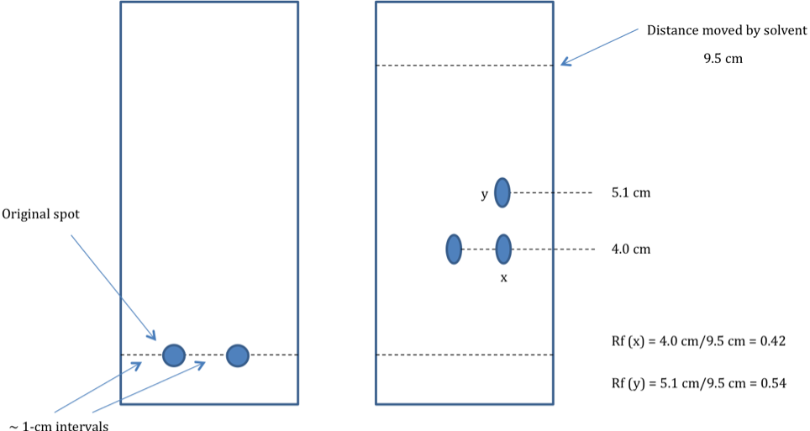
Part II
- Interpret the UV-Vis spectrum for your caffeine sample by comparing it to the spectrum of pure caffeine. Is your sample pure? Does it contain other compounds? What information can you glean about the impurities on the basis of the UV-Vis data?
- Plot UV absorbance versus concentration of the standard. What is the extinction coefficient of caffeine?
- Determine the concentration of your caffeine sample.
- Calculate the actual % caffeine in your dry sample of caffeine.
- Discuss the % caffeine obtained by comparing it to the expected value of caffeine present in tea leaves.

Part III
- Interpret the data using the spectrum obtained for a pure sample of caffeine and IR tables that your instructor will make available to you. Is your sample pure according to your IR data? Explain.

Integration of results
- Do the results obtained using TLC, UV-vis, and IR agree with each other? For instance, are the results consistent with respect to the level of impurities detected and the chemical properties of these impurities?
- Discuss the accuracy of TLC, UV-vis, and IR to assess the purity of your sample and identify sources of experimental errors. As part of this discussion, consider answering the following questions. Does the presence of a spot with the same Rf value as the one for pure caffeine proves that your sample contains caffeine? Does the presence of a UV signal at the same wavelength as the one observed for pure caffeine proves that your sample contains caffeine? How does the presence of impurities affect the calculation of the % caffeine in your sample? How could you be sure that your sample contains caffeine?

Conclusion
- Summarize the main findings of this laboratory experiment.
- Provide a take-home message.
- How could the experiment be improved in the future?

